

**YEAR: 8**

**SUBJECT: SCIENCE**

**TEST: Matter**

**TIME: 50 mins**

**QUESTIONS: Part A: Multiple Choice Questions (10 marks)**

**Part B: Short Answer Questions (29 marks)**

**Part C: Extended Answer Question (5 marks)**

**TOTAL MARKS: 44 marks**

**DO NOT WRITE ON OR MARK THIS PAPER**

**Part A: Multiple Choice Questions (1 mark each)**

1. Which of the following is ***not*** a physical property of substances?
2. the density of a substance
3. the strength of a substance
4. the temperature at which a substance will boil
5. how a substance reacts when combined with another substance
6. According to the particle model:
7. all matter is made of atoms that have no mass and are too small to be seen with the naked eye.
8. some matter is made of atoms that have mass and are small, but can be seen with the naked eye.
9. all matter is made of atoms that have mass and are small, but can be seen with the naked eye.
10. all matter is made of atoms that have mass but are too small to be seen with the naked eye.
11. Why is the particle model called a ‘theory’?
12. it is still being worked on
13. it is still very new
14. it was discovered by an individual rather than by a team
15. it accurately explains a wide range of observations and is supported by reliable evidence
16. Melting point is the temperature at which a
17. liquid changes to a gas.
18. solid changes to a gas.
19. liquid changes to a solid.
20. solid changes to a liquid
21. Describe the particles in a solid. The particles in a solid are
22. strongly attracted to each other so the solid has a definite shape.
23. strongly attracted to each other so the solid does not have a definite shape.
24. weakly attracted to each other so the solid has a definite shape.
25. weakly attracted to each other so the solid does not have a definite shape.
26. The state of matter with the strongest force of attraction between the particles (closest together are):
27. Solids.
28. Liquids.
29. Gases.
30. Both solids and liquids.
31. What is usually required for a change in the state of matter of a substance? A change in the
32. type of atoms.
33. number of atoms.
34. chemical potential energy of the atoms.
35. amount of heat energy.
36. As a solid object is heated, its particles:

a. vibrate less rapidly and cause it to contract.

b. vibrate more rapidly and cause it to expand.

c. attract each other more, causing contraction.

d. shrink in size so the gaps between them increase.

1. Four different substances were transferred from a test tube to a beaker. The table below shows changes of shape or volume which occurred.

|  |  |  |
| --- | --- | --- |
| **Substance** | **Did it change its shape when transferred?** | **Did it change its volume when transferred?** |
| A | YES | YES |
| B | YES | NO |
| C | NO | YES |
| D | NO | NO |

Which one of the substances do you think was solid?

1. A
2. B
3. C
4. D
5. Which of the following describe what is occurring to the particles during melting? The particles…
6. vibrate less rapidly and causes contraction of the volume.
7. vibrate more rapidly and causes expansion of the volume.
8. attract each other more, causing contraction of the volume.
9. expand in size.



**YEAR: 8**

**SUBJECT: SCIENCE**

**Name________________________________________________  
  
Class ____________**

**Part A: Multiple Choice Answers (1 mark each)**

Put a cross (X) through the correct answer.

|  |  |  |  |  |
| --- | --- | --- | --- | --- |
| **1** | a | b | c | **d** |
| **2** | a | b | c | **d** |
| **3** | a | **b** | c | d |
| **4** | a | b | c | **d** |
| **5** | **a** | b | c | d |
| **6** | a | b | c | **d** |
| **7** | a | b | c | **d** |
| **8** | a | **b** | c | d |
| **9** | a | b | c | **d** |
| **10** | a | **b** | c | d |

Part A: Part B: Part C:

Multiple Choice Short Answer Extended Answer TOTAL

/5

/44

/10

/20

/29

|  |  |
| --- | --- |
| **I CAN STATEMENTS** | **QUESTIONS** |
| **MUST**  Uses the particle model to briefly explain and predict the properties and behaviour of solids, liquids and gases. | 1, 3, 4, 5, 6, 7, 9, 11, 12, 13, 14, 15, 18, 19, 20 |
| **SHOULD**  Uses the particle model to explain and predict the properties and behaviour of solids, liquids and gases. | 2, 8, 13, 17, 19, 20, |
| **COULD**  Uses the particle model to explain in detail and predict the properties and behaviour of solids, liquids and gases. | 10, 16, 20 |

**Part B: Short Answer Questions**

1. Draw the particles in a solid, liquid and a gas. (3 marks)

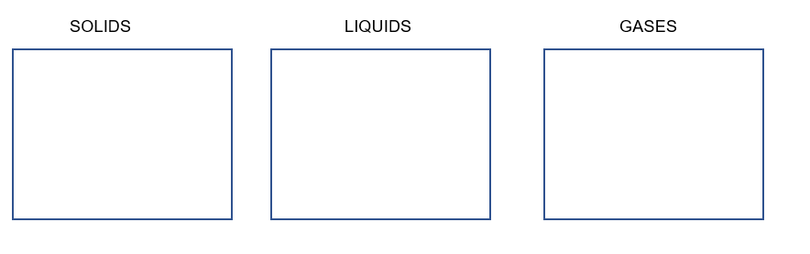

**Solids Liquids Gases**

1. Identify the state of matter and the names of the processes occurring between each change of state using the word bank below. (4.5 marks)

WORD BANK:  
Liquid Evaporation Sublimation Freezing Melting

Solid Condensation Deposition Gas

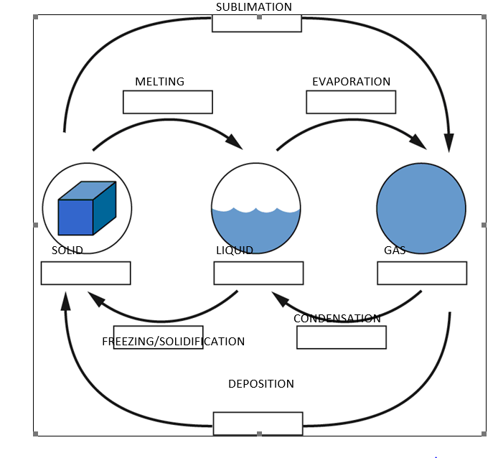

Freezing

13. Which one of the states of matter is said to be compressible? Describe why this state can be compressed while the others cannot. (2.5 marks)

**Gases (0.5 mark). This is because there are large spaces between the particles in a gas (1 mark), while the particles in liquids and solids do not have spaces between them (1 mark).**

14**.** **Define** chemical property. Write an **example** of a chemical property of a state of matter to support your answer. (2 marks)

**How a substance behaves in a chemical reaction (1 mark) 1 Example: Reaction with acid, permanent colour change or any reasonable example. (1 mark)**

15. **Define** the following properties: (2 marks)

Density

**It is the mass of a certain volume of a substance. (1 mark)**

Viscosity

**It is the thickness or ‘gooiness’ of a liquid. (1 mark)**

16. Explain why a cork will float in water, but a rock will not. (2 marks)

**Cork is less dense than water (1/2 mark) whereas rock is denser than water (1/2 mark)**

**If a substance is less dense than the water, it floats. (1 mark)**

17. Describe the differences between expansion and contraction in terms of energy of particles. (4 marks)

**Expansion: Increase temperature and/or more energy and or increase speed (1 mark)**

**particles move further apart (1 mark)**

**Contraction: Decrease temperature and /or less energy and or decrease speed (1mark)**

**particles move closer (1mark)**

18. Classify the substances in the box below as elements, compounds or mixtures. Place them in the appropriate list below and give a reason for your choice in each instance.

|  |  |  |  |  |
| --- | --- | --- | --- | --- |
| Pure water | Sand and water | Neon gas | Sodium chloride | Mercury |
| Magnesium | Helium gas | Copper carbonate | Smoke | Carbon dioxide gas |

a. (i) Elements: (1 mark)

Neon gas, mercury, magnesium & helium gas (2 elements = ½ mark each, total of 1 mark)

(ii) These substances are elements because: (1 mark)

Elements are made up of one type of atom (1).

b. (i) Compounds: (1 mark)

Pure water, sodium chloride, copper carbonate & carbon dioxide (2 compounds = ½ mark each, total of 1 mark)

(ii) These substances are compounds because: (1 mark)

Compounds are made up of different types of atoms (1).

c. (i) Mixtures: (1 mark)

Sand and water and smoke (1/2 mark each).

(ii) These substances are mixtures because: (1 mark)

Mixtures are made by mixing together two or more elements or compounds (1).

19 (a) Draw a diagram of a density tower and place the following substances in their correct order. Remember most dense on the bottom, least dense on the top. (2 marks)

|  |  |
| --- | --- |
| Substance | Density (g/cm3) |
| Soap | 1.45 |
| Petrol | 0.77 |
| Water | 1.00 |
| Honey | 2.76 |

**In the diagram as you go from bottom to the top, order of layers should be**

**Honey, Soap, Water and petrol (All 4 in correct order, 1 mark, just 1 mistake -1/2 mark)**

19 (b) Describe your reason for the above choice of order? (1 mark)

**Students can describe either using the results from the table or using the idea of density or any other reasonable answer (1 mark)**

**Part C: Extended Answer Questions**

20. If you place a reed diffuser that smells nice on one side of the room, on a warm day you can typically smell it very quickly even if standing on the other side of the room.



1. Explain how air freshener in a container can diffuse quickly with warmer temperature.

1. Draw a diagram using the particle model to support your answer. (5 marks)

**a) Diffusion is the spreading out of particles from a liquid or gas (1 mark)**

**As the temperature increases kinetic energy of particles increases (1 mark)**

**Particles move faster (1 mark)**

**Smell spread out faster on warmer day - 1**

**b) A suitable diagram similar to the one given below – (1/2 mark) and (1/2 mark for pencil and ruler)**

